Keep these pages for your records. Bring the signed contract, completed audition information sheet, and 3 judge rubrics with Name and Song information filled out at the top to your audition.

Audition Information & Contract 2020-2021
Being a member of CenterStage! is an amazing opportunity and high honor. With this recognition comes responsibilities. To avoid issues during the school year, please read and commit to the following:

- Auditions are open to incoming 9th and 10th grade students. You must be a member of one of the LHHS choirs in order to audition.

- There are some expenses involved which total around $100:

- CenterStage Polo: $25, Contribution towards Espree Ad: $7-10, CenterStage Formal Uniform: $40-$60, Contribution towards Directory Ad: $5-7
- Batteries for mics, supplies, music, sound equipment, and alterations: cost varies
- These expenses should be paid by October of the school year. We do not fundraise for these expenses in the choir department. You provide: Black dress shoes and belt for men, Black shoes and sheer/flesh tone hose for women.

- We will rehearse once a week after school from 4:15-6:00 PM or before school from 7:30-8:45 AM. There will be extra rehearsals to prepare for the Spring Show and there may be times when members will miss school for performances and work must be made up. Students must be committed to these rehearsals. Any conflicts need to be worked out well in advance. We typically rehearse one time before school starts in August. Be sure to mark your calendar for the CenterStage Work Day when the date is sent in the summer.

- All CenterStage performances are mandatory. Unexcused or unexpected absences will result in removal from the group.

- Failure of a class for a nine-week grading period will result in probation for the student for the following weeks. For any subsequent failure in any subject during the school year, the CenterStage member will be removed from the group.

- This group is a select group in which each member must be committed. Attitude or attendance problems will result in removal from the group. As a CenterStage member, you always represent Lake Highlands High School. Your character and your image affects the CenterStage group.

- School and district rules apply any time you are representing CenterStage and Lake Highlands High School, both at school and when traveling away from campus. Violations from school and district rules can result in removal from the group. (See the RISD extra-curricular policy).

- All CenterStage members are expected to be leaders in the LH choir department. CenterStage members are expected to prepare for the All-Region Choir audition in September and perform at Solo and Ensemble Contest in February.
Audition Information

Auditions will be held Monday, May 17 and Tuesday, May 18 in the LHHS H Bldg Choir Room (H E154). Park in the lot off of White Rock Trail and enter the front doors of the H Building. There will be signs and student helpers to guide you to the audition room from there. You may sign up for an audition time slot using this link: https://www.signupgenius.com/go/30E0D4FAAAA2DA0F49-centerstage4 or scan the QR code on this page.

- Auditions are closed to the public. Please note that all RISD COVID protocols still apply. ANYONE in the building must wear a mask over their nose and mouth and observe social distancing. Students will be masked at all times during their auditions.

- Singers will perform ONE accompanied song of their choice AND My Country ‘Tis of Thee (a cappella).

- Singers must be accompanied by a pianist/guitarist or a “Karaoke style” CD or track on a phone, tablet, or MP3 player (this will be plugged into our sound system - make sure it works!) (Karaoke means: No lead vocals on the track and no a cappella singing). Students auditioning may not play an instrument during their audition. A rock, pop, Broadway, jazz, contemporary, country, etc. song will be suitable for the audition. The music must be memorized and the singer must use the microphone provided. Please make sure lyrics are school appropriate. Be thoughtful about your song choice, for example: if you are a Soprano, don’t sing an Alto range song from the radio. Remember that you are auditioning to be a part of a group – if you belt your entire audition, this does not show that you will blend in a group. Keep your song length to no more than 2 minutes. Songs that go beyond the time limit may be cut short by the panel of judges.

- Sing a song that suits YOUR voice and fits YOUR range
- Sing like YOU, not the artist who originally recorded the song.

- After performing your song of choice, singers will sing one verse of “My Country ‘Tis of Thee” a cappella. You may choose your starting pitch (find a key that is comfortable for your voice and shows a typical range for your voice part). Ask your choir director for help if you need it. If you do not know what starting pitch, Mrs. Worrall will choose one for you. This selection should be well-rehearsed. Learning tracks available here:

- Auditions will be judged by two choir directors outside of Lake Highlands and Mrs. Worrall.

- Judges will be listening and watching for vocal quality and ability, accuracy and intonation, appropriate selections, stage presence, and attitude/motivation/rehearsal discipline/work ethic (LH director only for this criteria).

- Stage presence, while by no means the only factor involved, is a very important part of your audition. This includes stage movement, poise and presentation, and facial expression.

- Audition Results will be posted by 4:00 PM on Friday, May 21st outside the choir room doors at LHHS and emailed to incoming students who auditioned. Please read the included LHHS audition policy.

CenterStage Rehearsal Expectations

- Be on time to rehearsal. Tardiness will be recorded.
- Work on your music in rehearsal and outside of rehearsal time when asked.
- During rehearsals, be considerate and respectful to your peers and the director. Divisive language or attitude will not be tolerated.
- Everyone will help with setting up and taking down sound equipment.
- If a rehearsal must be missed, notify the director via email well in advance and before the absence.

Keep these pages for your records. Bring the signed contract, completed audition information sheet, and 3 judge rubrics with Name and Song information filled out at the top to your audition.

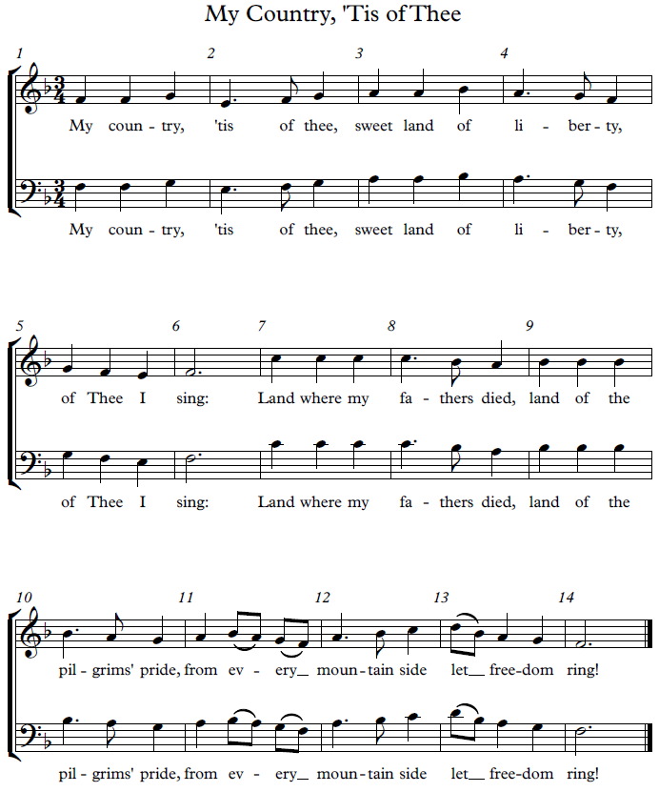

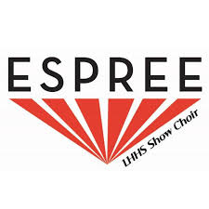
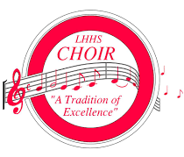
Audition Schedules and Information are available in class or in the choir room
CenterStage! and LHHS Choir audition results will be posted outside the High School choir room doors after 4:00 p.m. on Friday, May 21st. CenterStage results will also be emailed to the address provided on audition forms/sign-up genius.
Espree results will be posted Friday, May 14th after 4:00 p.m. outside the choir room doors.
LHHS Choirs Audition Policy:
If you have questions: A part of our work as teachers is teaching students how to handle auditions: how to handle good news with grace, how to handle bad news with dignity, how to ask for feedback in a constructive and professional way, how to make future decisions carefully and as thoughtfully as possible, and so on. It is in this spirit that the following procedures are set in place.
Students: In the case of most auditions, very few people actually achieve the complete result for which they hoped. Some get part of what they want, some fall short. We hope you imagine what you might accomplish in the department; not matter what choir you are placed into.
Remember that every single student is going through “audition pains;” over-celebration of good news can be very hurtful to those who don’t have as much to celebrate. On the other hand, one can be disappointed with his or her own results and still happy for a peer. Please be as sensitive to others as you want them to be to you.
Anyone with questions about his or her audition can contact us, via email, starting 48 hours after the final audition results have been posted. We will only respond to email requests; this is so that we can receive and review detailed information in writing, which serves as a better teaching tool. The 48 hour “cooling off” period allows for a chance for a student to more carefully consider what it is that they want to know in order to learn from the audition.
Parents: While we understand your eagerness to act as your child’s advocate, and while we will certainly respond to your requests for information, we respectfully ask that you let your child sort this out on his or her own first. After all, soon enough most of these students will be auditioning as adults, and need to learn how to gather information and ask the right questions, in the right way.
We are fiercely proud of every student in our care, and promise to give each student in each choir the same extraordinary care and attention! Break a leg!
Sincerely,
Mrs. Worrall, Ms. Gilbertson, and Mr. Wade
Claire.Worrall@risd.org
(469) 593-1351

If there are any questions, please email Claire.Worrall@risd.org or call (469) 593-1351. Please sign below – both parent/guardian and student. Bring this completed contract to your audition.

We understand and accept the audition policies, obligations, requirements, and responsibilities of the group, should

_____________________________________ be selected to CenterStage! for 2021-2022.
student name - printed

_________________________________ ___________________________________
Parent/Guardian Signature Student Signature

_________________________________ ___________________________________
Parent/Guardian Email Student Email

Please bring this completed form when you come to your audition along with three audition rubrics for the judges with the top section completed on all three sheets.

Student Name: ____________________________________________

T-shirt size for polo: (circle one) S M L XL XXL (adult sizes only)

Parent Name: _____________________________________________

Parent Email (PRINT CLEARLY): _____________________________________________

Parent Phone Number: ______________________________________

Answer the following questions:

1. Why do you want to be in CenterStage?

2. What other activities will you be involved in next year? When do these activities practice/rehearse? (For example – cheerleading, football, volleyball, track, baseball, piano lessons, theatre, band, orchestra, golf, soccer, musical)

3. Why would you be a valuable member of CenterStage?

4. How long have you been in choir? Are you involved in any other music activities or do you play any instruments?

Audition Rubric

Name:___________________________ Grade Level for 2021-2022________

Voice Part (check all that apply): S1 S2/A1 A2 T1 T2/B1 B2

I would like to be considered for Sound Tech: YES or NO (circle one)

Song 1: _________________________________________
Song 2: My Country Tis of Thee in the key of: ______ (starting pitch; Mrs. Worrall will choose if you don’t know)

 |  | Superior Ability | Proficient Ability | Developing Ability | Comments
Voice Quality | (25)_______
 | Tone Quality | Even tone; well-supported, vibrant | Even tone; mostly supported | Gap b/w chest and head register; needs more support
 | Musicianship | Expression and use of dynamics | Some expression and use of dynamics | Inconsistent use of expression and dynamics
Stage Presence | (25)_______
 | Soloist Qualities | Performance is polished, confident, and engaging | Performance is confident and engaging but lacks polish | Singer seems unsure, hesitant
 | Movement | Has plan for movement, seems comfortable on stage | Some movement and seems comfortable | No movement, seems somewhat uncomfortable
 | Appearance | Eye contact and pleasant facial expression | Some eye contact and expression | Lacks eye contact and expression
Accuracy | (20) _______
 | Pitch/Rhythm | Accurate and stayed with accomp track | Just a slight bit of inaccuracy, stayed with accomp track | Some inaccuracy and got off from accomp track
 | Preparation | Performed from memory without errors | Performed from memory; a few minor memory lapses | Performance with major memory lapse
 | Intonation | Consistently stays in the center of the pitch | Pitches mostly centered, minor number of intonation flaws | Melody is recognizable but many flat/sharp pitches
Pop Vocal Style | (15) _______ | Would blend well with other voices | Potential for blending in a group of voices | Might have trouble blending with a group
Selection | (15) _______ | Appropriate for voice and audience | Appropriate for audition, some range/voice issues | Appropriate for audience, but significant range/voice issues

Total: ________ __________________________________(Judge Signature) 1 2 3

Audition Rubric

Name:___________________________ Grade Level for 2021-2022________

Voice Part (check all that apply): S1 S2/A1 A2 T1 T2/B1 B2

I would like to be considered for Sound Tech: YES or NO (circle one)

Song 1: _________________________________________
Song 2: My Country Tis of Thee in the key of: ______ (starting pitch; Mrs. Worrall will choose if you don’t know)

 |  | Superior Ability | Proficient Ability | Developing Ability | Comments
Voice Quality | (25)_______
 | Tone Quality | Even tone; well-supported, vibrant | Even tone; mostly supported | Gap b/w chest and head register; needs more support
 | Musicianship | Expression and use of dynamics | Some expression and use of dynamics | Inconsistent use of expression and dynamics
Stage Presence | (25)_______
 | Soloist Qualities | Performance is polished, confident, and engaging | Performance is confident and engaging but lacks polish | Singer seems unsure, hesitant
 | Movement | Has plan for movement, seems comfortable on stage | Some movement and seems comfortable | No movement, seems somewhat uncomfortable
 | Appearance | Eye contact and pleasant facial expression | Some eye contact and expression | Lacks eye contact and expression
Accuracy | (20) _______
 | Pitch/Rhythm | Accurate and stayed with accomp track | Just a slight bit of inaccuracy, stayed with accomp track | Some inaccuracy and got off from accomp track
 | Preparation | Performed from memory without errors | Performed from memory; a few minor memory lapses | Performance with major memory lapse
 | Intonation | Consistently stays in the center of the pitch | Pitches mostly centered, minor number of intonation flaws | Melody is recognizable but many flat/sharp pitches
Pop Vocal Style | (15) _______ | Would blend well with other voices | Potential for blending in a group of voices | Might have trouble blending with a group
Selection | (15) _______ | Appropriate for voice and audience | Appropriate for audition, some range/voice issues | Appropriate for audience, but significant range/voice issues

Total: ________ __________________________________(Judge Signature) 1 2 3

Audition Rubric

Name:___________________________ Grade Level for 2021-2022________

Voice Part (check all that apply): S1 S2/A1 A2 T1 T2/B1 B2

I would like to be considered for Sound Tech: YES or NO (circle one)

Song 1: _________________________________________
Song 2: My Country Tis of Thee in the key of: ______ (starting pitch; Mrs. Worrall will choose if you don’t know)

 |  | Superior Ability | Proficient Ability | Developing Ability | Comments
Voice Quality | (25)_______
 | Tone Quality | Even tone; well-supported, vibrant | Even tone; mostly supported | Gap b/w chest and head register; needs more support
 | Musicianship | Expression and use of dynamics | Some expression and use of dynamics | Inconsistent use of expression and dynamics
Stage Presence | (25)_______
 | Soloist Qualities | Performance is polished, confident, and engaging | Performance is confident and engaging but lacks polish | Singer seems unsure, hesitant
 | Movement | Has plan for movement, seems comfortable on stage | Some movement and seems comfortable | No movement, seems somewhat uncomfortable
 | Appearance | Eye contact and pleasant facial expression | Some eye contact and expression | Lacks eye contact and expression
Accuracy | (20) _______
 | Pitch/Rhythm | Accurate and stayed with accomp track | Just a slight bit of inaccuracy, stayed with accomp track | Some inaccuracy and got off from accomp track
 | Preparation | Performed from memory without errors | Performed from memory; a few minor memory lapses | Performance with major memory lapse
 | Intonation | Consistently stays in the center of the pitch | Pitches mostly centered, minor number of intonation flaws | Melody is recognizable but many flat/sharp pitches
Pop Vocal Style | (15) _______ | Would blend well with other voices | Potential for blending in a group of voices | Might have trouble blending with a group
Selection | (15) _______ | Appropriate for voice and audience | Appropriate for audition, some range/voice issues | Appropriate for audience, but significant range/voice issues

Total: ________ __________________________________(Judge Signature) 1 2 3

